**Week 6 Sprint 1**

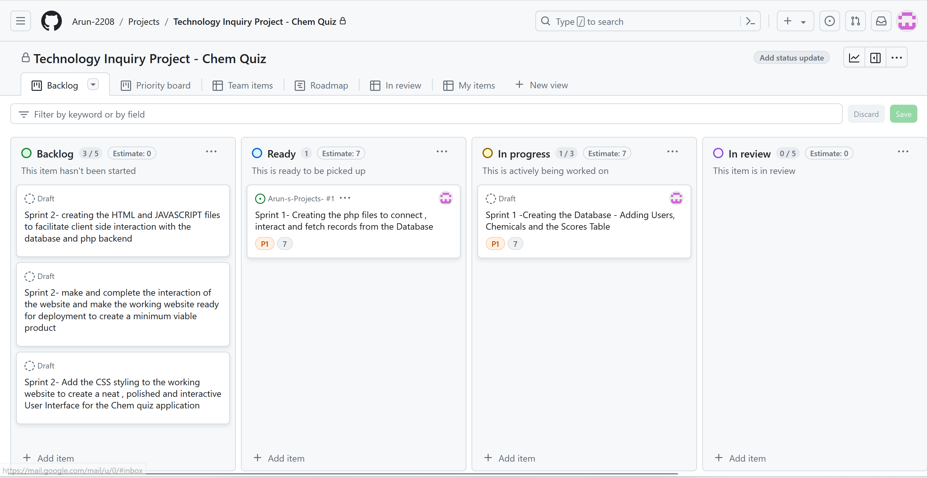

Week 7 Sprint 1

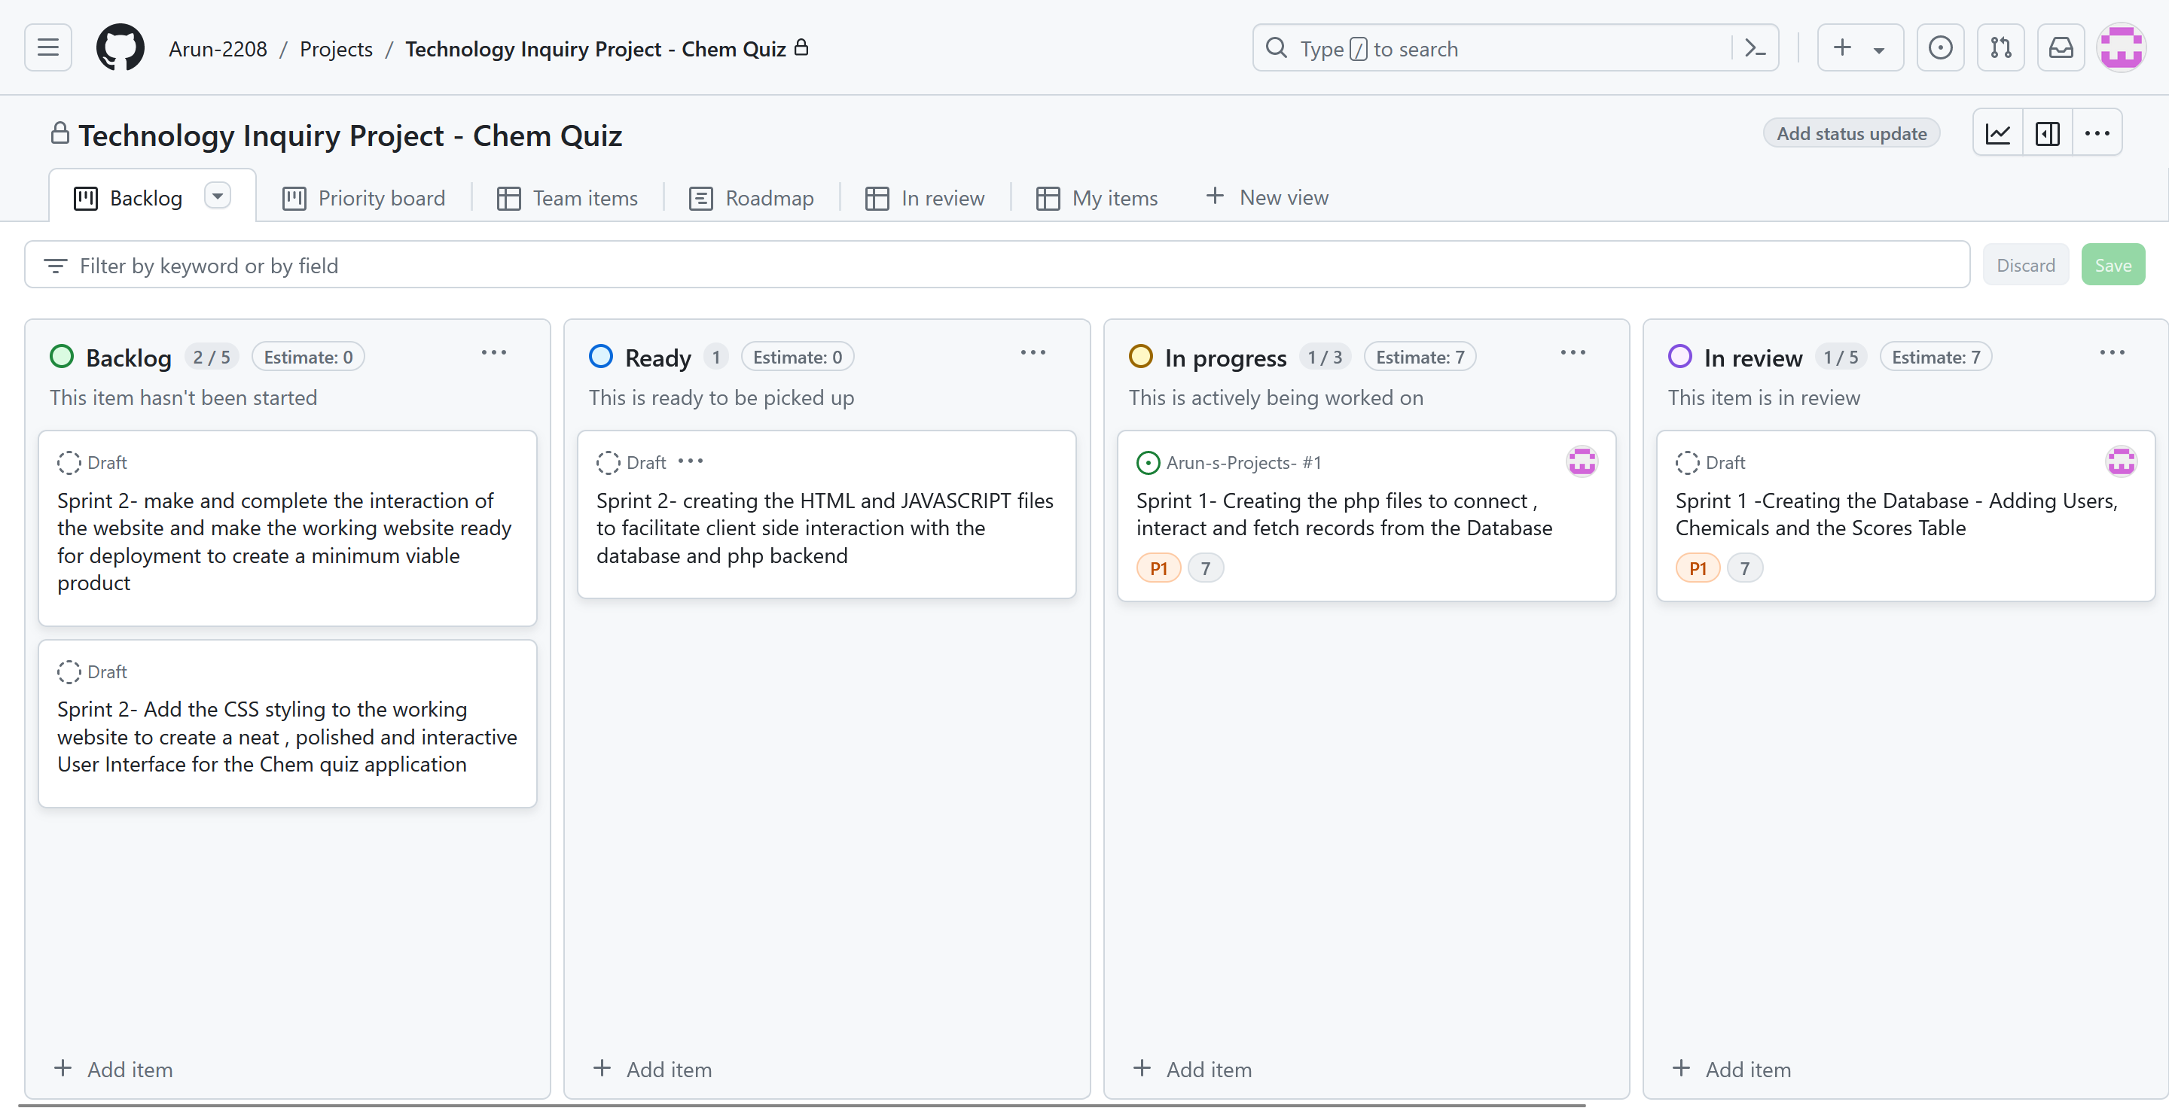

Database Creation and Population

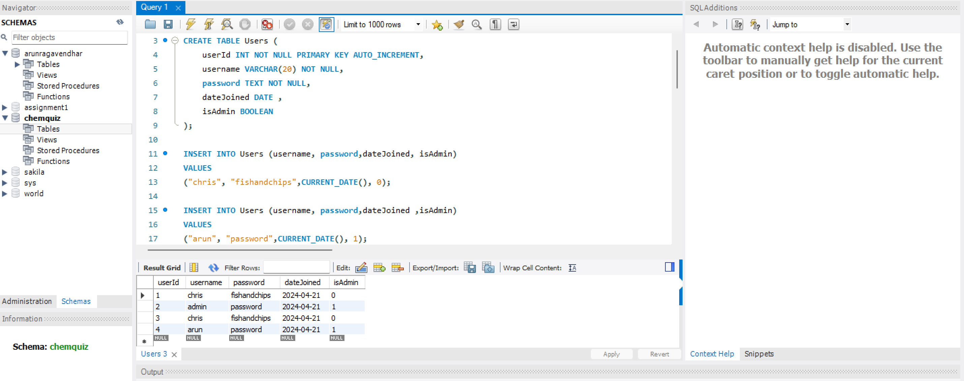

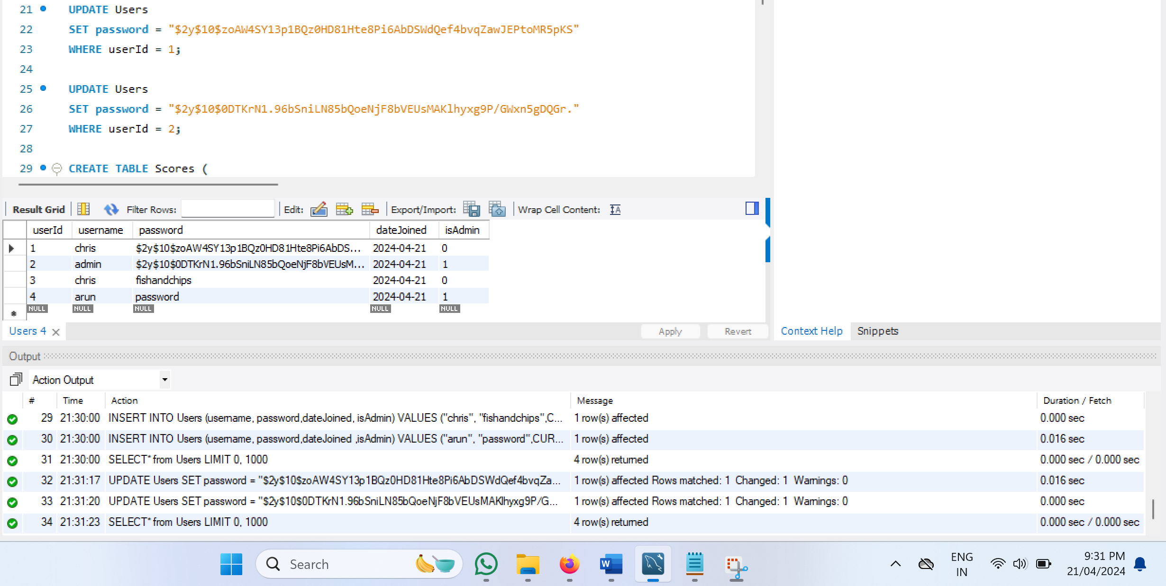

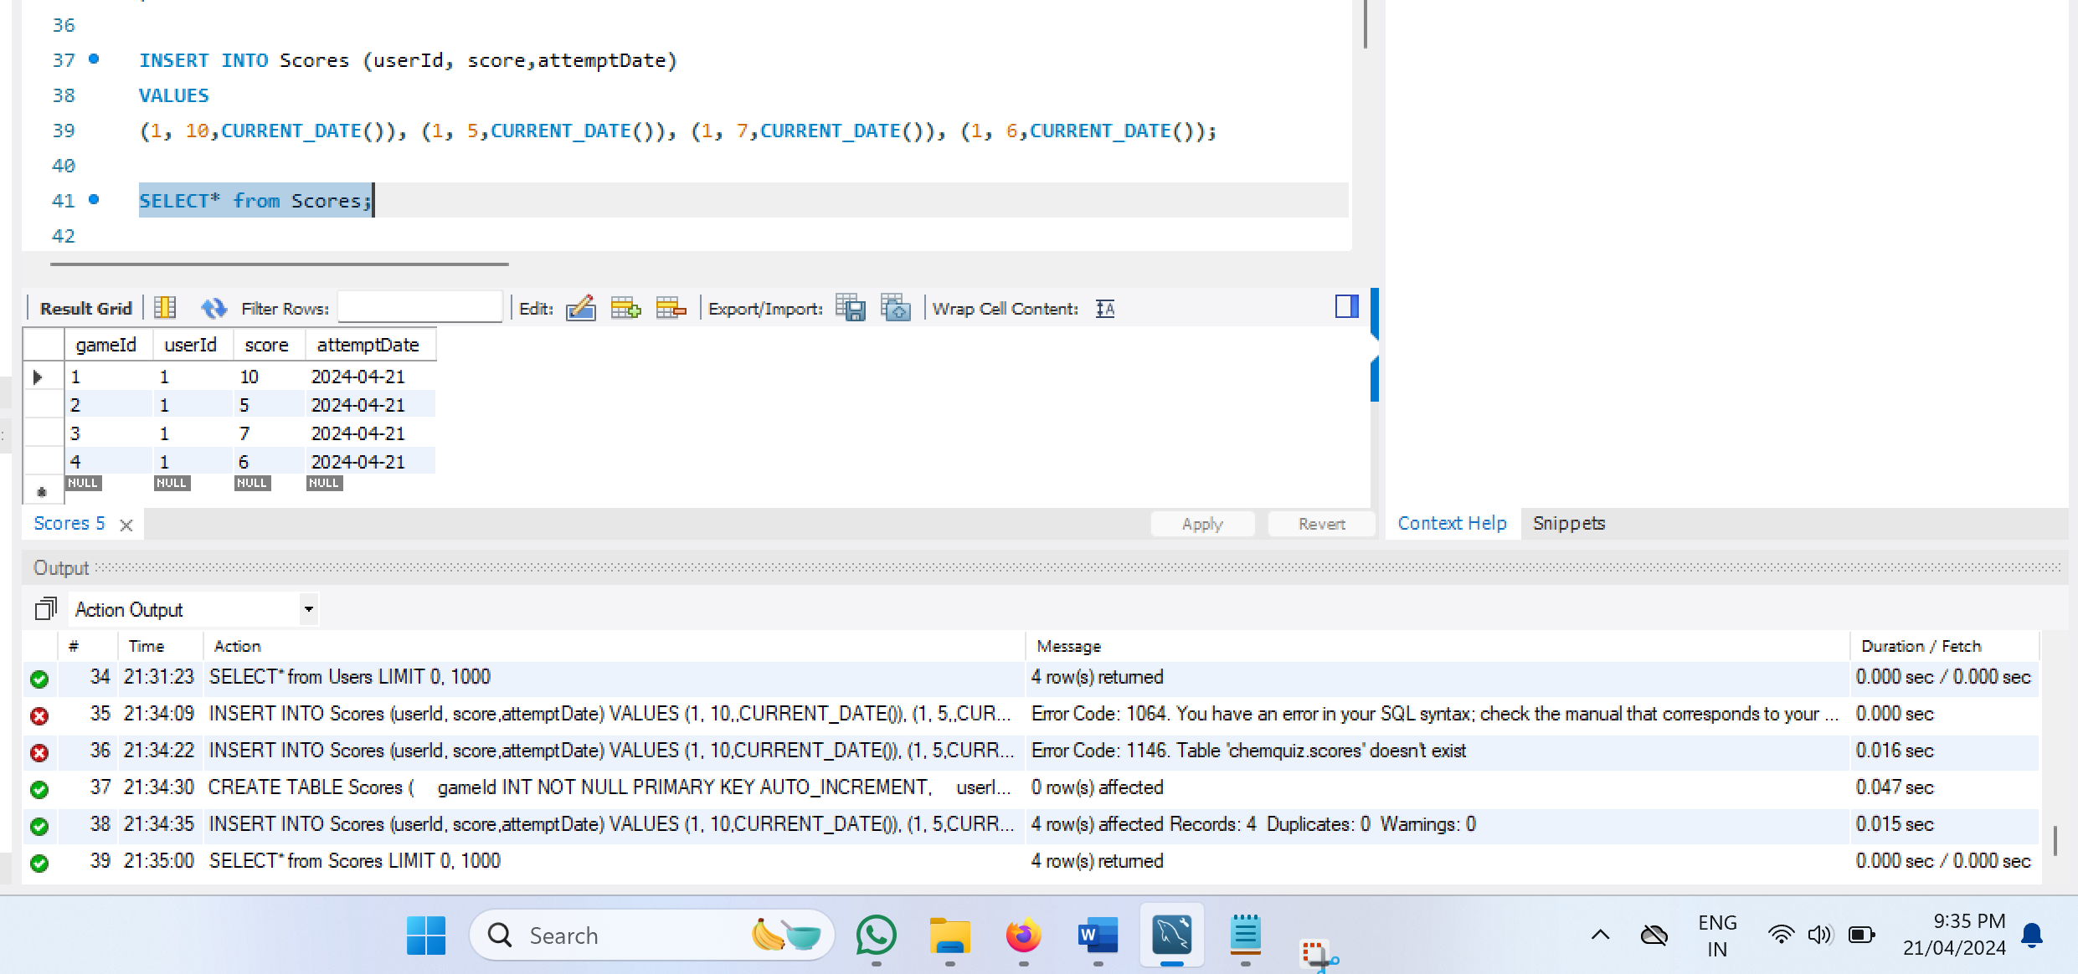

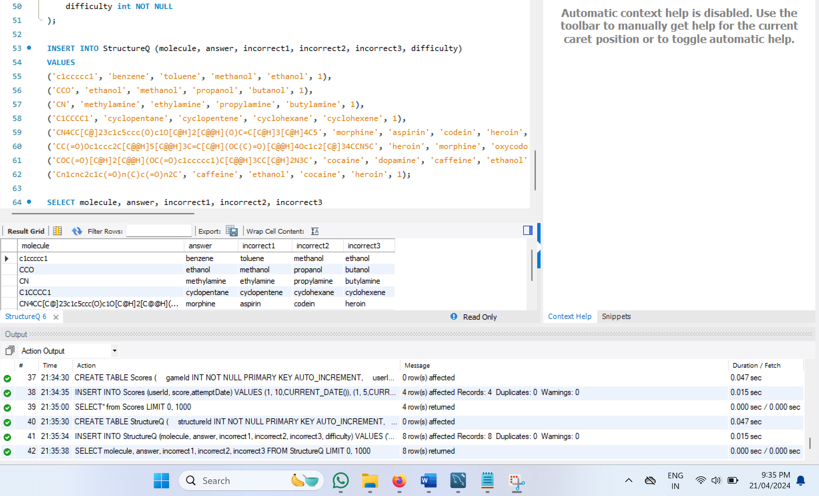

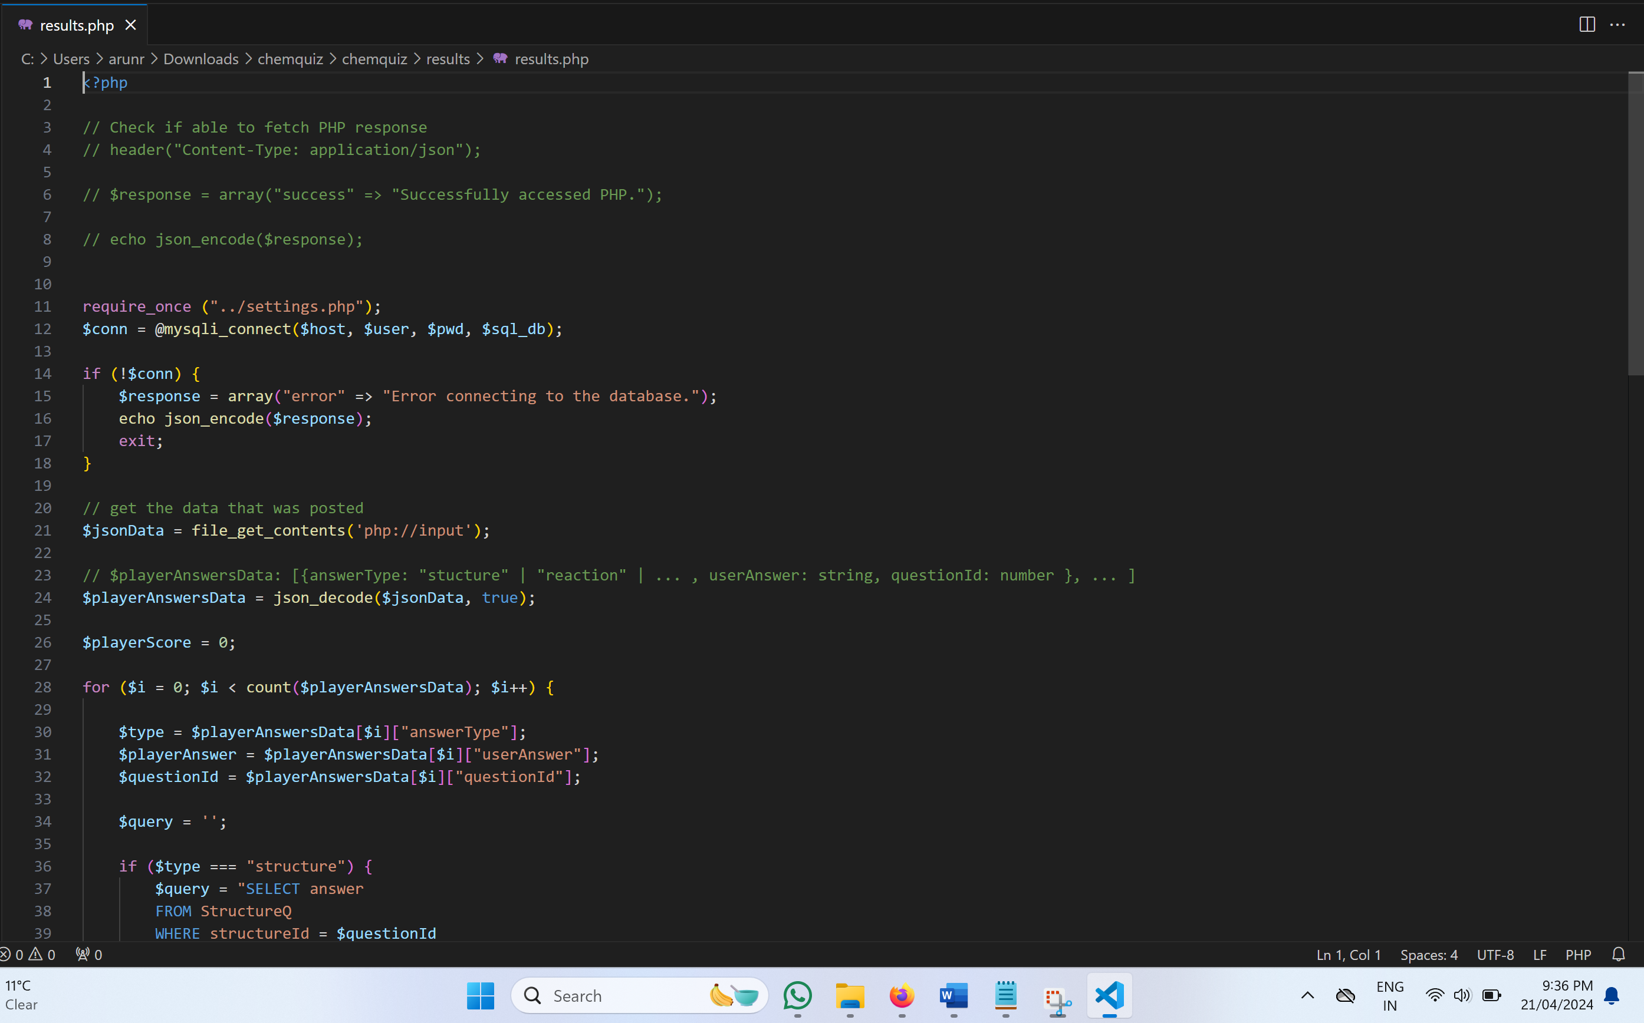

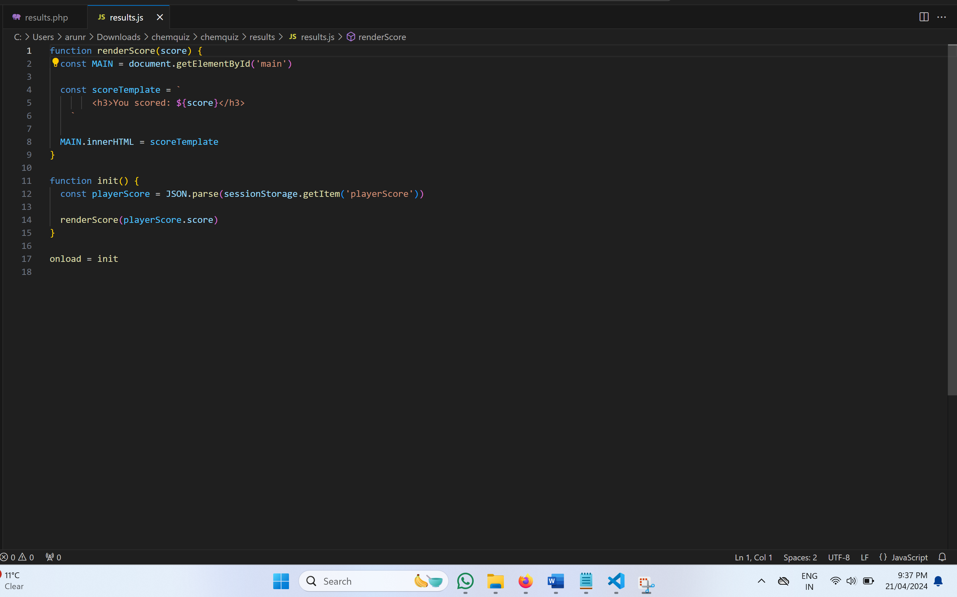

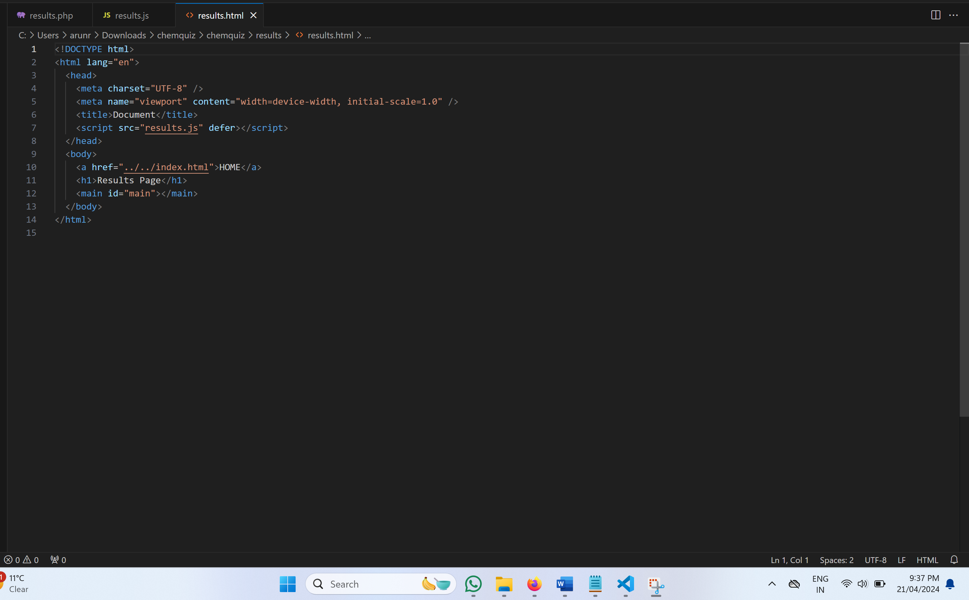

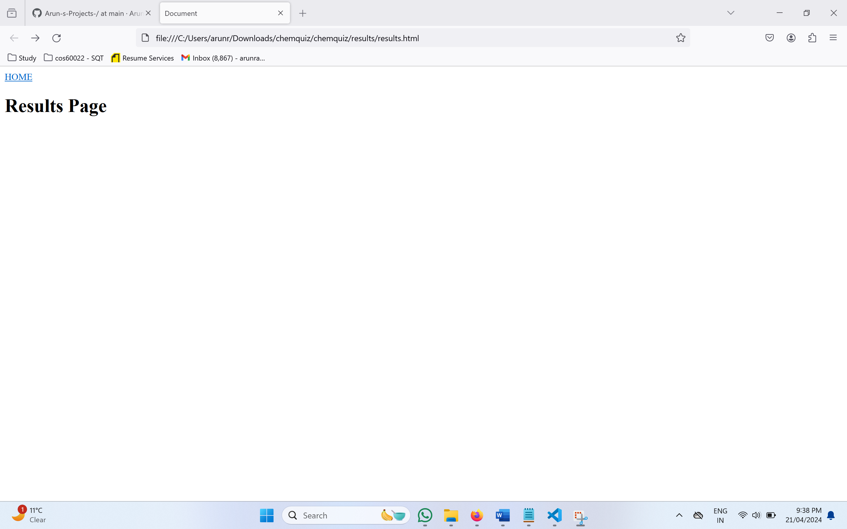

Week 9

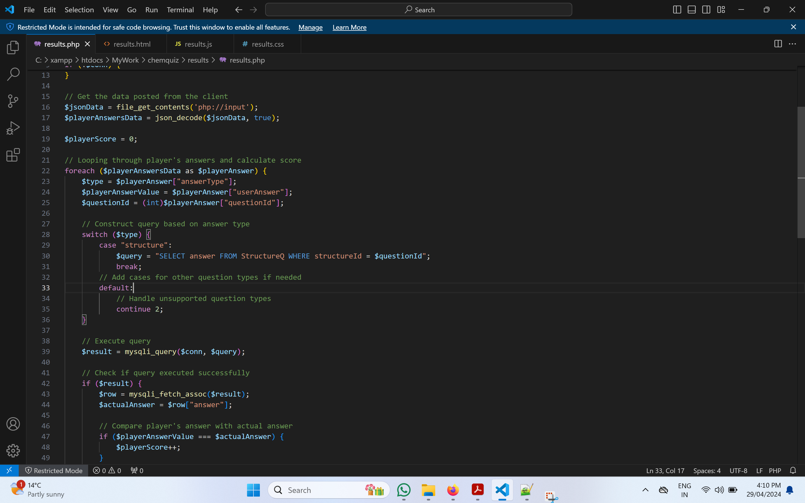

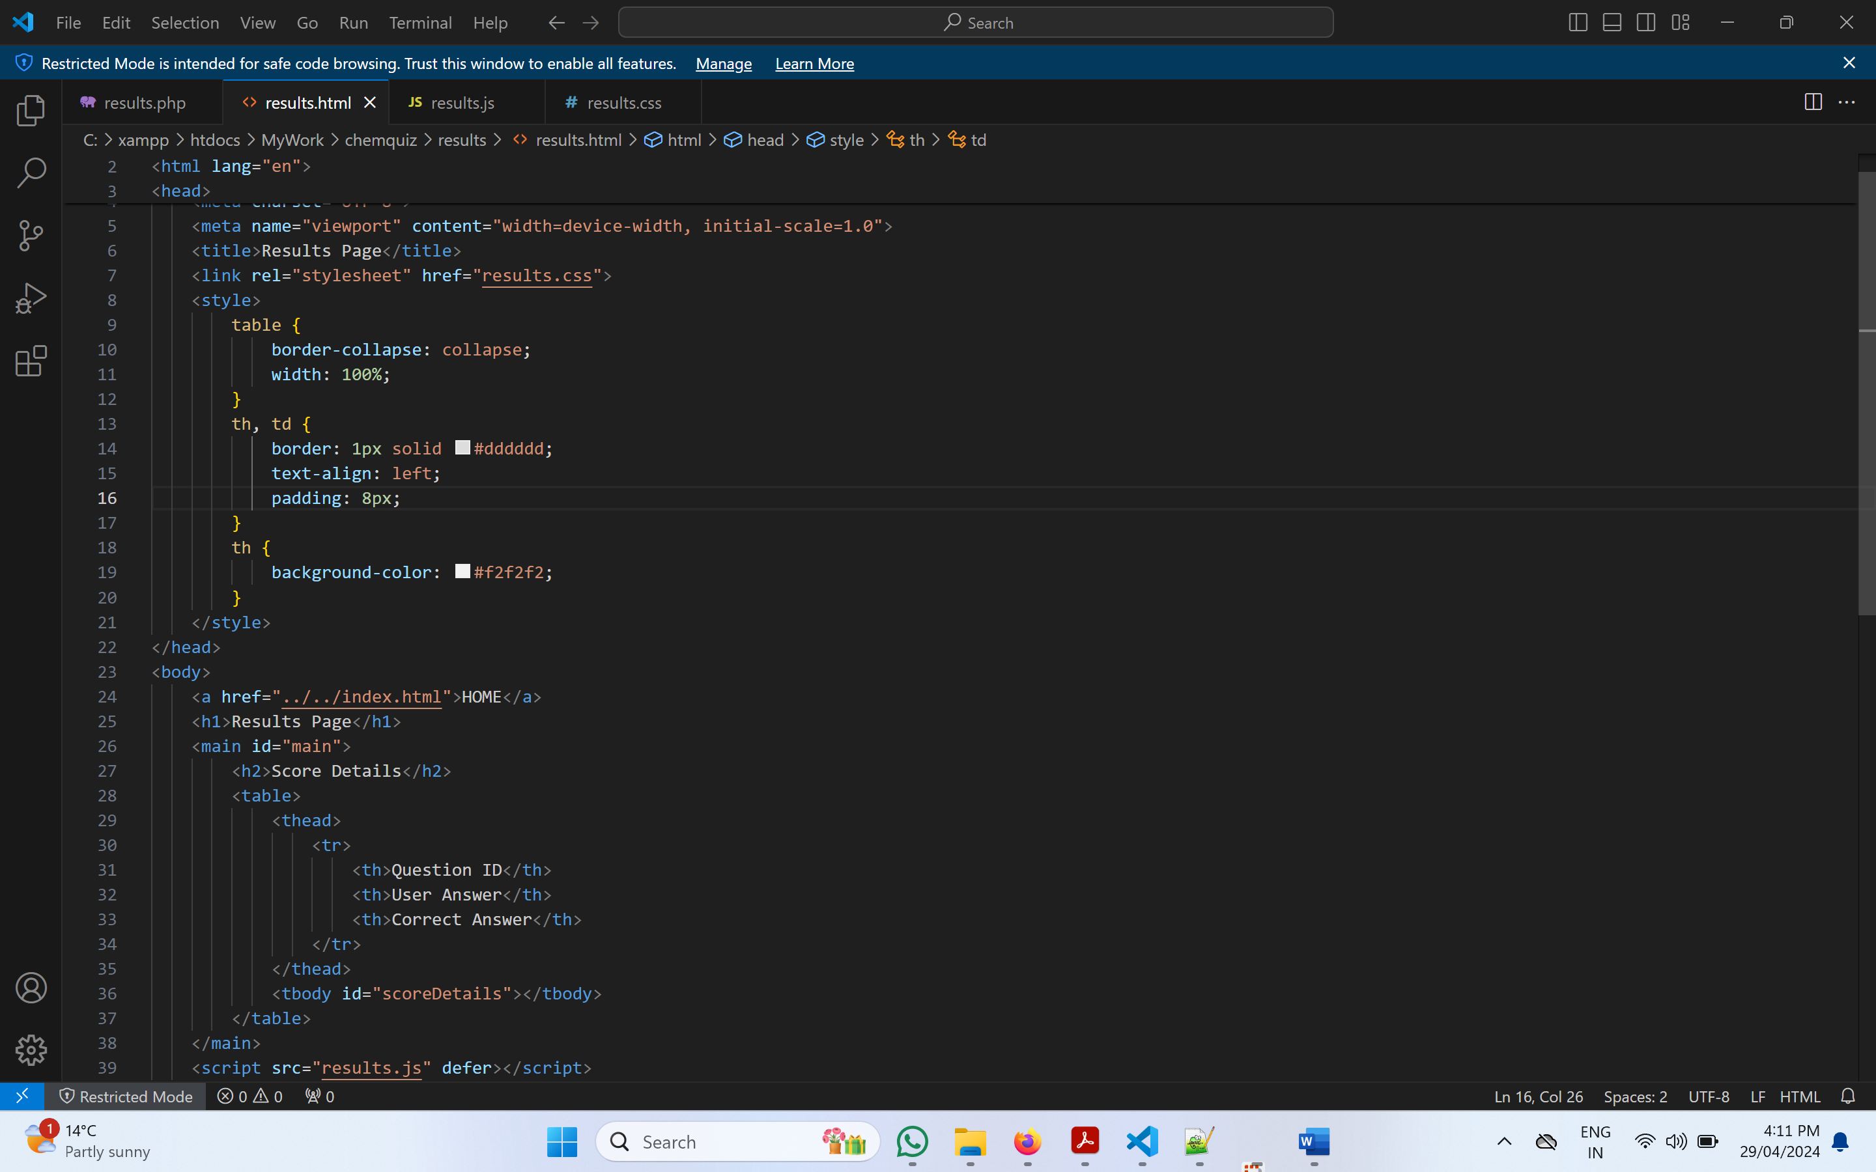

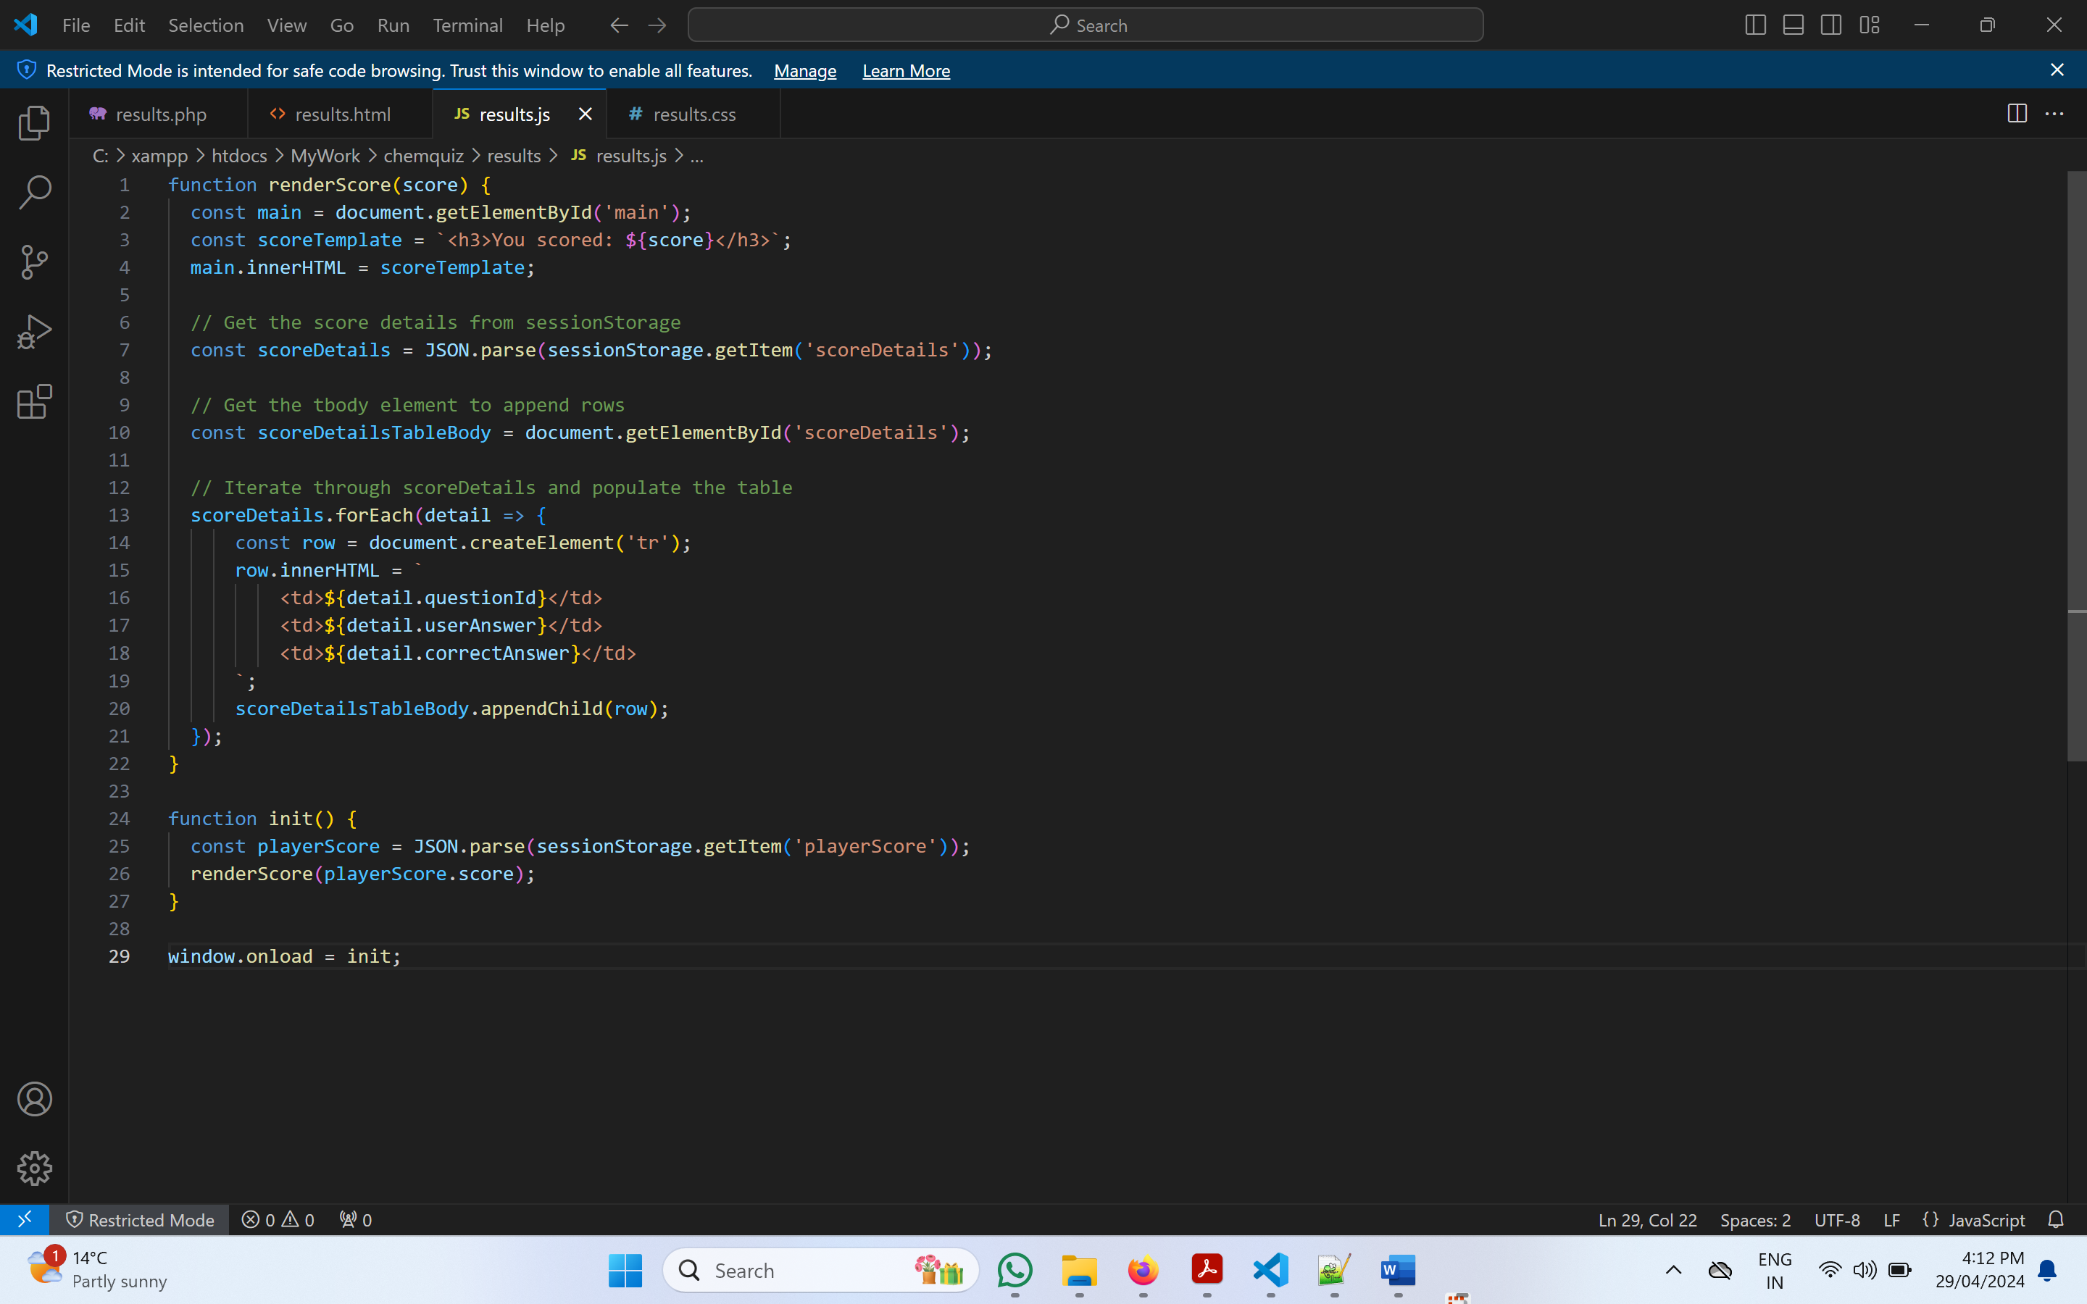

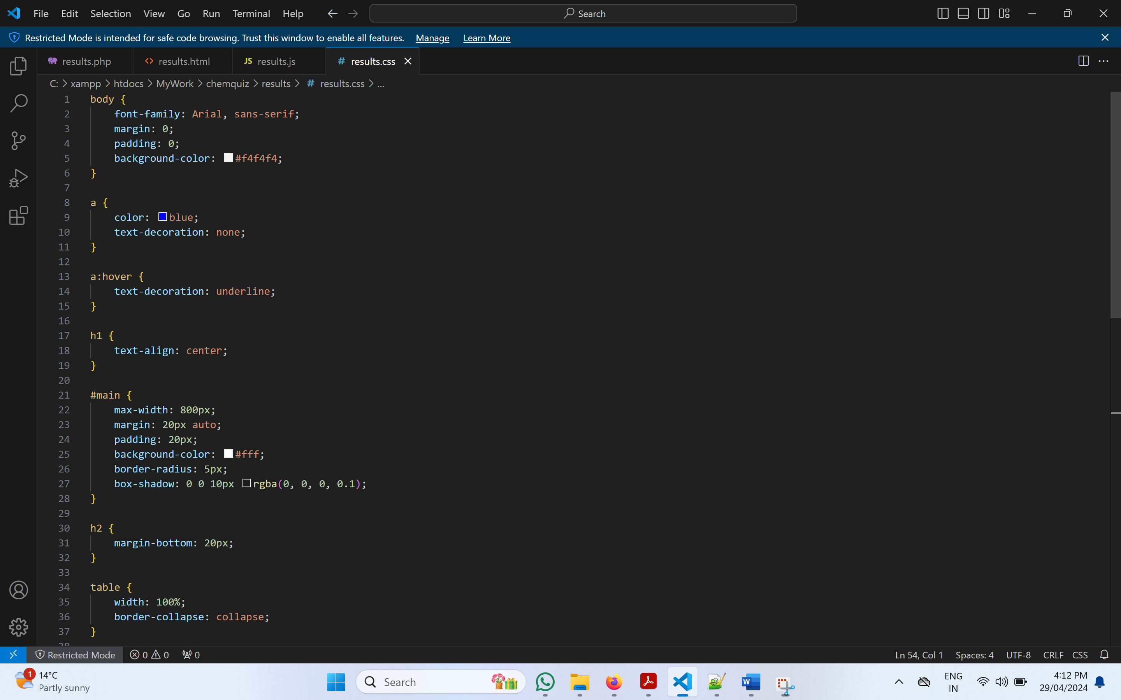

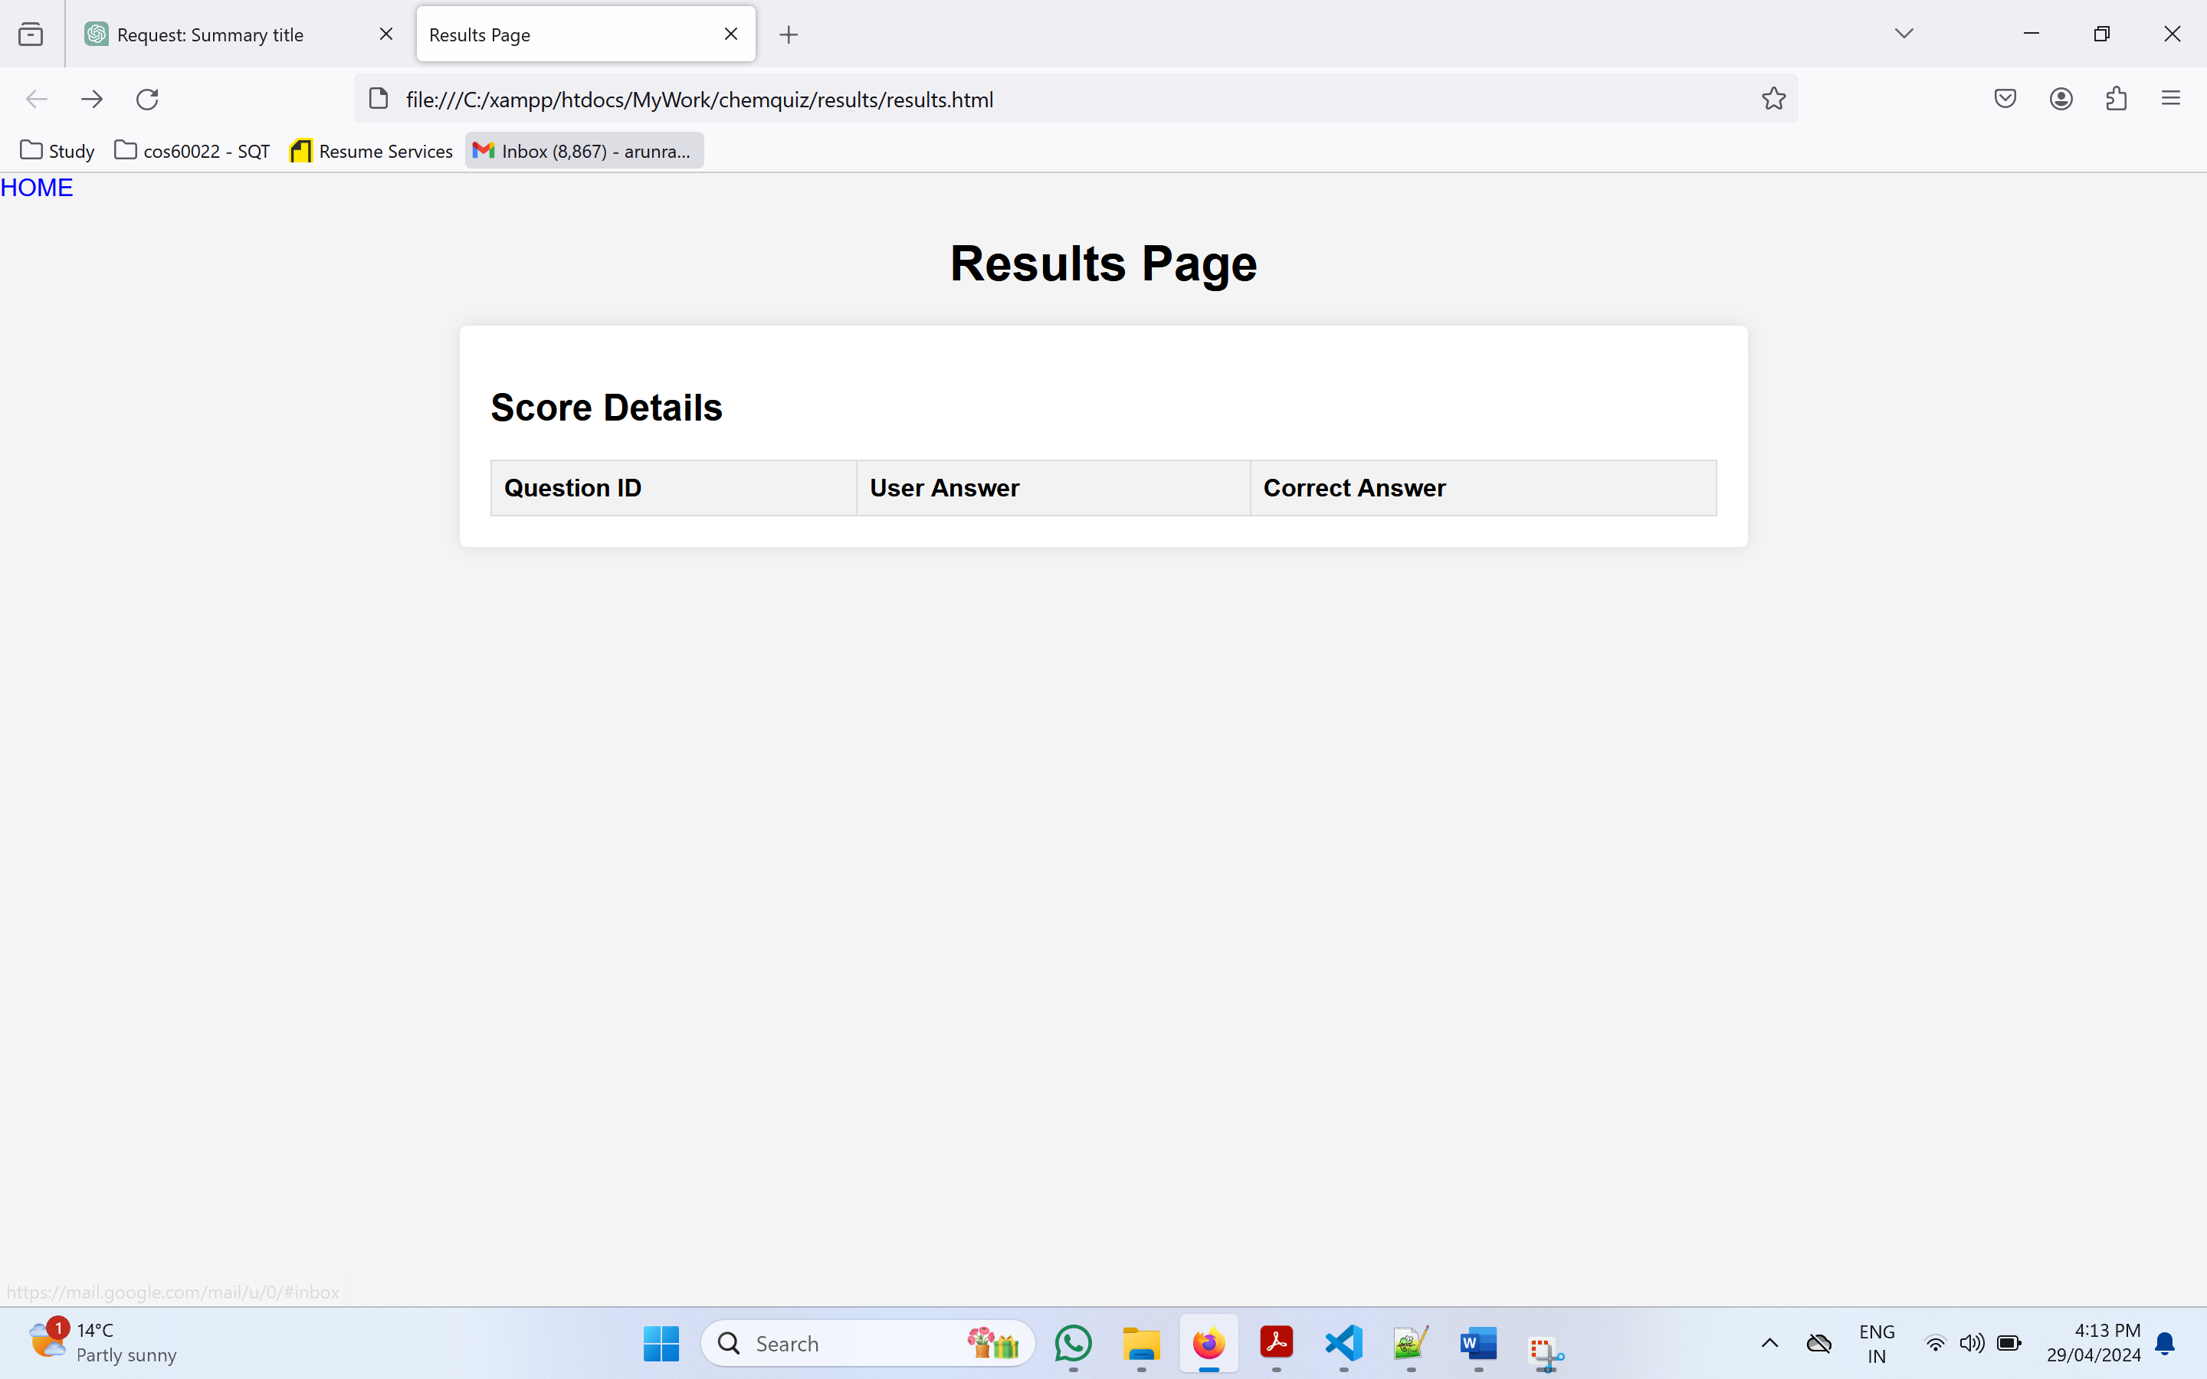

What technical work I did

What management activity I did

What bugs did I fix

Innovations and enhancements I brought to the project

Challenges faced

Learning curve

And getting beyond that

Error debugging

Arrangements , evidence and proofs of the things

Database schema contributions , design contributions

Technical suggestions

Reviews

Quiz representation ideas that I put in

Follow the ULOS and make sure u have answered all of them

Adapting to the cultural perspective and adapting to all people suggestions.

But still bringing out the best possible content and contribution

Final draft mail to chris

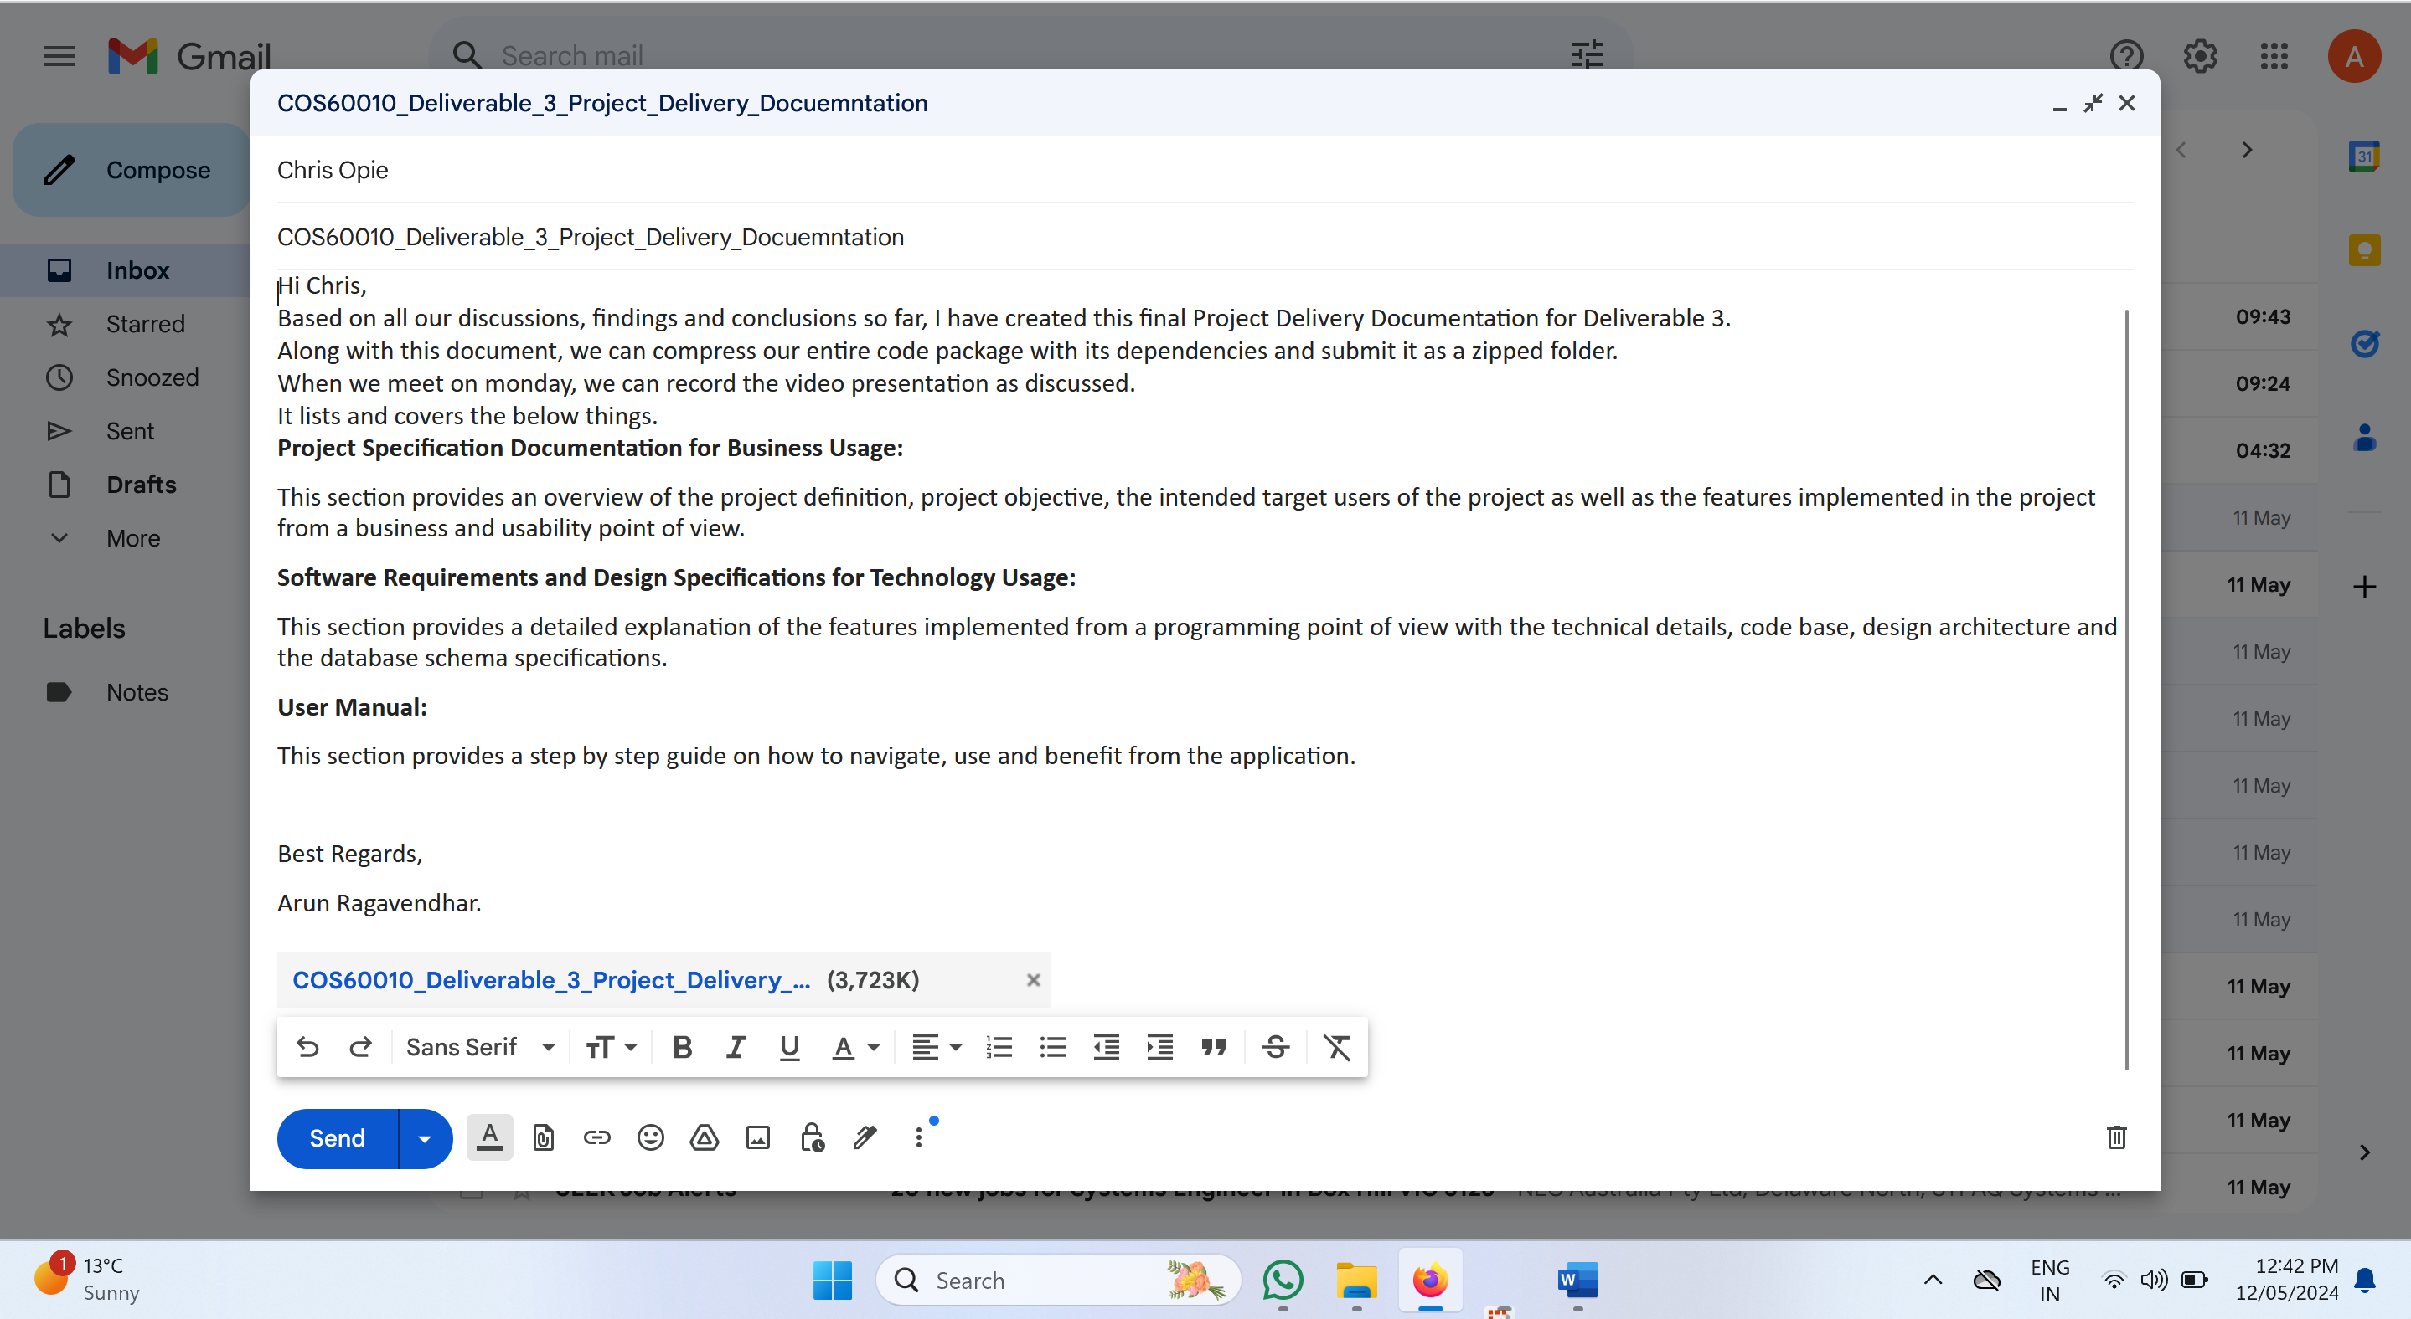

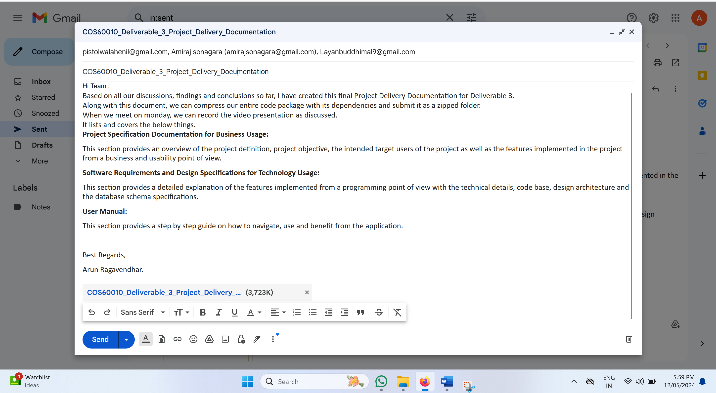

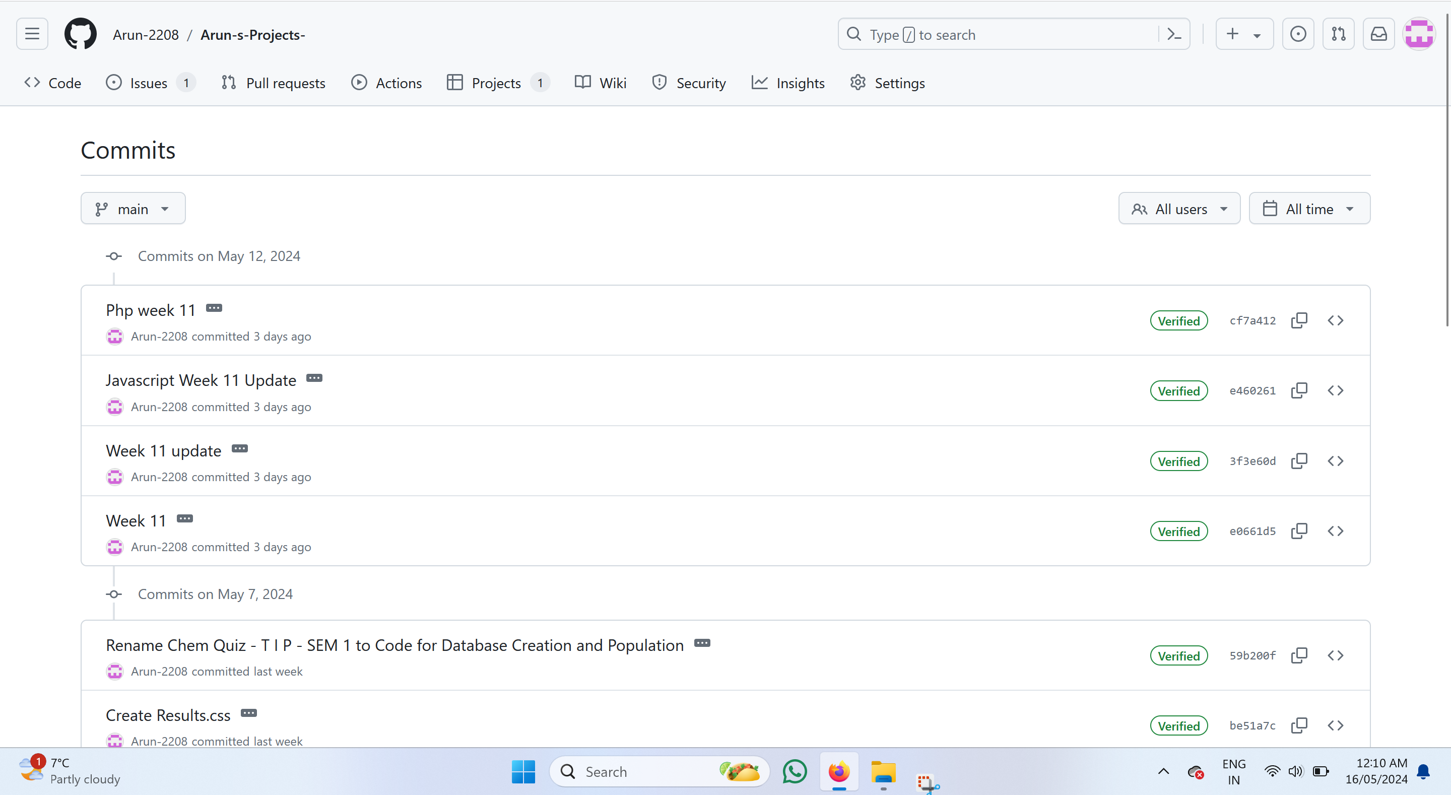

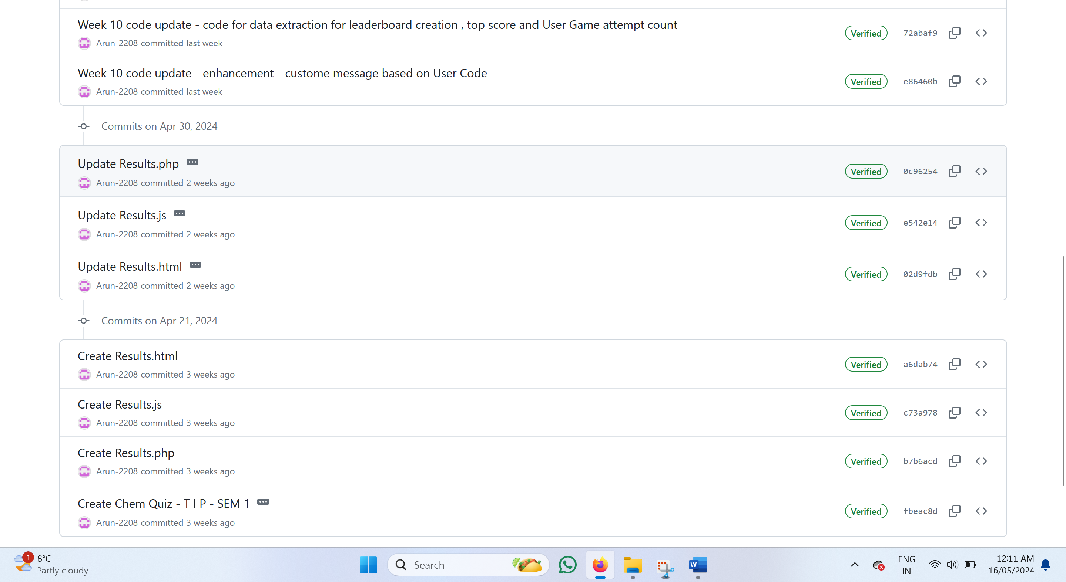

Figure.35: WhatsApp chat discussions

Figure.36: Task splitting for sprints

Figure.37: Coordinating and booking a room for team meetings

Figure.38: Providing sample templates for team members

Figure.39: Team Project Documentation sent to team members through mail

Figure.40: Provided technical inputs for team members to work upon and uploaded the files on canvas